

Game design doc for GL Live
Designer: Liu chen ke
V 0.0.3

The index
1 What's GL Live? 3
2Entrance of GL Live 3
3Register & Login 3
3.1Login Screen: 3
3.2The input box: 4
3.3Connect: 5
3.4Register: 5
3.5Forget Password: 6
3.6General Conditions 7
4User profile 7
4.1General data for user 7
5Edit profile 8
7Main menu 9
8Friend system 11
8.1How to add a friends? 11
8.2Actions for friends 12
9Message 14
9.1Message box 14
9.2Read message 15
9.3Write message 16
9.4System message 16
9.5User message 16
10Trophy 17
10.1Trophy 17
10.2Compare games 19
11Push notification 19
12Address list of GL live team 21
13Q&A 21

What's GL Live?
Since online features are becoming more and more importance on iPhone applications. The GL Live is a online mutual system to make user easily to communicate, looking for competitor or parter, and so on. Everyone who is playing gameloft iphone game can easy to login GL live with his GL account. If user doesn't have GL Account, he can easy register a one. The steps of registration is very simple, only need 1 minute. The GL account system is mainly constitutes of the following sections:
-User profile system
-Friends system
-Message system
-Real-time Chat
-Trophy system
-Push notification
Then let's see the details of each parts.

Entrance of GL Live
The entrance of GL Live should appear on root of main menu with clear visibility.
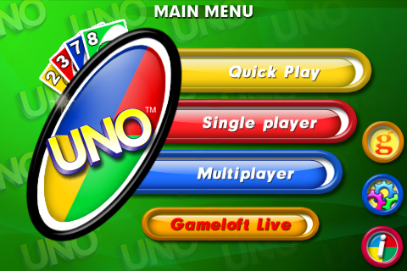

Register & Login

Login Screen:

//click the “Connect”
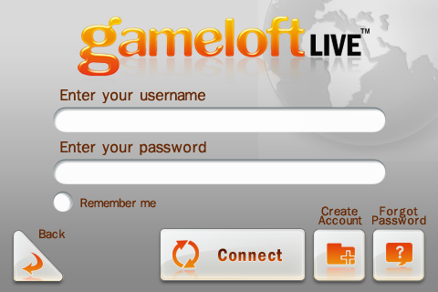
//server returns the result: fail or success
GLXPlayerUser::SendLogin(char * name, char * password);

//click the “Forget Password”
//when server received this message, emails the password to user
GLXPlayerUser::sendRetrievalPassword(char * userName);
1.Get email;

2.Get email flag(receive gameloft email);

3.Get user TOTAL score of all games, which will be shown in main page after user login.

4.Get ad. picture and news(text) of main page after user login;

5.Get online friend count; We can get it after get all friend list, but it will make login waiting time too long. Can you provide a simple one such as GetOnlineFriendCount()?

The input box:
We use the iphone default input system . When user touch the ID or password box, it will switch to input screen like this:
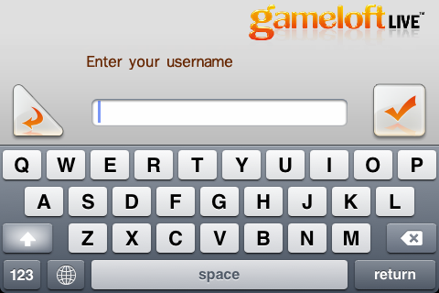
After user input his username done, and touch the ok return(or OK), the screen will switch to login screen with the inputted word.

Connect:
Connect to GL live, if user identity validate failed(or connection fail), will display a error message screen.
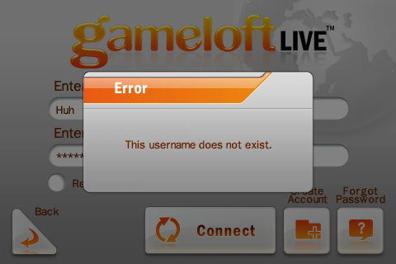

Register:
If user has no GL Account, he need touch the Register button to create a new GL account!
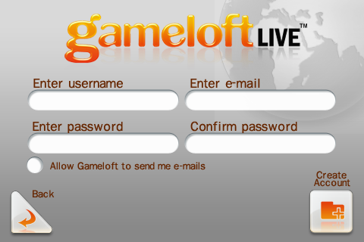
//click the “Create Account”
//server returns the result: fail or success
GLXPlayerUser::sendRegister(char * name, char * password, char * email, char *country, bool emailFlag);

This is the basic information screen, user must fills every items(Email format must be aa@bb.cc ). If registes is successful, it will ask user would like login now.

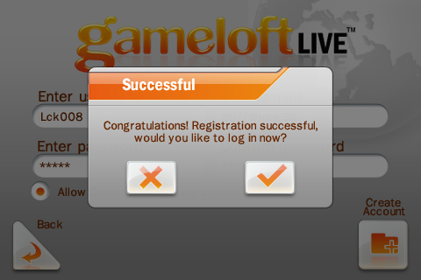

Forget Password:

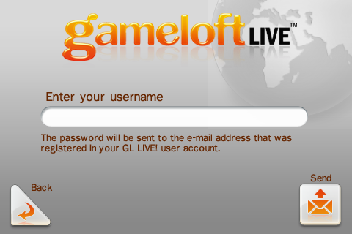

If user forgets his/her password, he can touch the Forget Password screen to get the password back. In forget password screen, he/she only need input his user name, password will be sent to the e-mail address that was registered in his/her GL LIVE! user account.

General Conditions
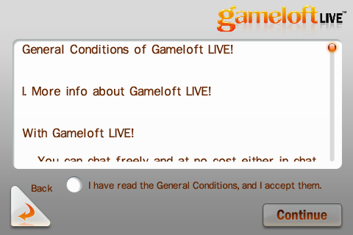

Before register, User must accept General Condition to continue.
Also, if the general conditions has changed, you may need send the new one to zhu jun wen(junwen.zhu@gameloft.com) to update it, and user need confirm it again while login.
The text resource of General Conditions here: trunk/resource/text/General_Conditions

User profile
Everyone who login the GL live has his/her own GL account.

General data for user
The GL account contains those information:

User name: It's an identity for every user and it's also the name to show to other player. it can be changed in profile setting page, but can't change to a exist one.
Password: it can be modified, if user turn on auto login option, it will log in automatically next time.
E-mail: Use to receive GL news (if he wish), and get password back if user forget. Every E-mail address is unique. Does not allow the reduplicate E-mail address. After registering, system will send a validated mail to the E-mail address, to validate if the E-mail address is ture.
Email flag: To agree&disagree receive gameloft mails.
Country: The personal informtaion of user.
Avatar: The icon of each user, he can use his own one( take a photo with iphone's camera or select a picture in iphone's album), also we will provide some default ones.
Score: It's a total g point of all gameloft games, each game will have several trophies and 2000 g points.
Friend list: Record the user's firends, more details in 1.3 Friends.
Message box: like a simple mail system, user can send message to other user and receivce system & user messages here.

Edit profile
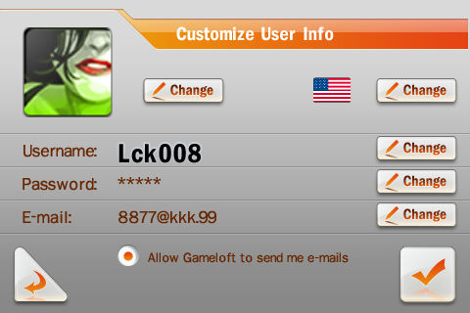
The follow items can be modified by user in Profile screen
- Username
- E-mail (The E-mail address is unique, if user change it to a existent one, the system will notice that he modify failed.)
- E-mail flag
- Password
- Avatar
- Country

Choose avatar:

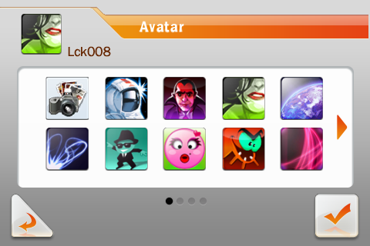
Import avatar
from album
We provide about some default avatars for user, also allow user import avatar from iphone's album. And user can max use 10 custom avatars.
Every custom avatar need be checked after uploading it in 72 hours.
It can be set as avatar only if allowed by gameloft.

Choose country:
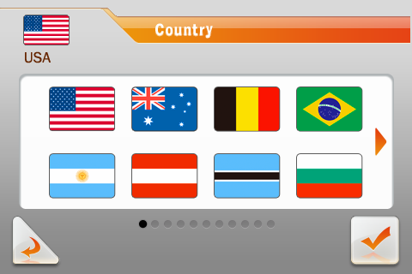

After registering, the system will detect the iphone's regional and language options and choose the current one automatically. But user also can change it here.

Main menu

After user login successfully, he will enter the GL live's main page. If he received new messages, it will prompt user at first time.
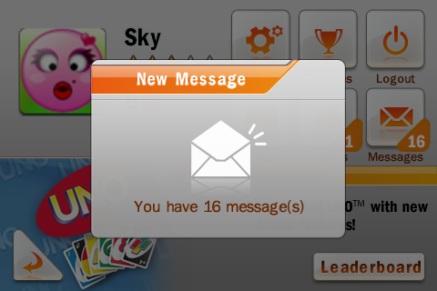
//after user login successfully, we need the info as follow:
//avatar, reputation, score, number of online friends, number of new messages(save on server before including personal and GL info)
//need to do
If user touch the message box, it will enter the mail box. If he touch the other area it will skip the message and enter the GL live Main menu.
Touch to enter
friend list

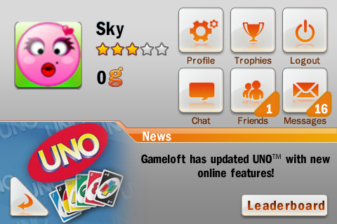
Touch to enter the
user profile edit screen
Touch to enter
trophy system
The friends and
message status
Touch to enter
the mail box
Touch to enter
the chat room

//click the avatar
Touch to enter
Leaderboard
//server returns the result: success or failed
GLXPlayerUser::sendUploadUserPhoto(char* data)

//click the trophy icon
//return the game IDs user owned
GLXPlayerUser::sendGetUserGameList(char * userName, int day, int limit)
//need to do
//return the game info: score, trophy, etc.
GLXPlayerGame::sendGetGameInfo(char * userName);

//click the message icon
//server returns the result: the message sent successfully or failed
GLXPlayerMessage::SendOnlineMessage(char * receiver, int type, char * title, char * body, int body_length);

//click the friends icon
//server returns the result: friend1's avatar, country, name, reputation, score, status(playing some game, or offline)
GLXPlayerUser::sendGetUserFriends()

Friend system

The GL live is a online mutiplayer community. So the friend system is absolutely necessarily.
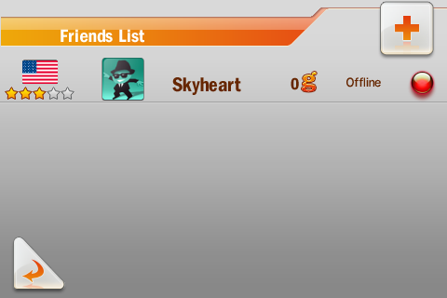

//click the “+”
//server returns the result: the request sent successfully or failed
//GLXPlayerUser::sendAddUserFriend(char * userName)

As the picture shows, we can see the friends':
        - avatar
        - country
        - name
        - reputation
        - score
        - status
It allows user adds 200 friends max, the order of array for friends is play the same game, online friends, offline friends.

How to add a friends?
There's 4 ways to add a friend:
- Go to friend list and touch the “+” button, then input the username that you want to add as your friend.
- In online multi player, you can touch the “+” button to add him/her as your friend, the “+” icon only appears when he/she is not your friend.
- In chat room, you can touch the “+” button to add him/her as your friend, the “+” icon only appears when he/she is not your friend.
- When you received a messages, the sender is not your friend, there's a add button on read message screen, you can touch the button to add him/her as your friend.
After you adding a user as your friend, his/her status is “waitting for confrimation” you only can do the actions after he/she accepting your friend invitation,

Actions for friends

When touch a friend in list will enter a new screen to do more actions

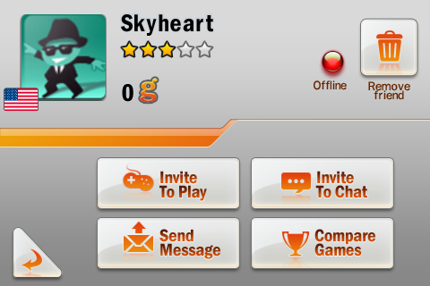

//click the “Invite To Play”
//maybe send a message to your friend, when your friend accept go to “multiplayer”

//click the “Invite To Chat”
//server returns the result: the message sent successfully or failed
GLXPlayerChat::SendChatMessage( char * username, char * message )

//click the “Send Message”
//server returns the result: the message sent successfully or failed
GLXPlayerMessage::SendOnlineMessage(char * receiver, int type, char * title, char * body, int body_length);

//click the “Compare Game”
//return the game IDs I owned
//GLXPlayerUser::sendGetUserGameList(int day, int limit);//mine
//need to do
//return the game info: score, trophy, etc.
GLXPlayerGame::sendGetGameInfo(char * userName);

Invite to play: Invite friend play the user's current game. Before game start here will be a confirmation: “Quick Play” and “Custom Game”, also you can disable this action if your game dont' support multi-player mode.
There are 2 situations:
      - The friend is playing the invited game: When he accepts, the user and he will go to create game screen.
      - The friend is not playing the invited game or not online we will send him/her a push notification, more detail please check chapter “push notification”

Invite to Chat:

It's realtime text chat.
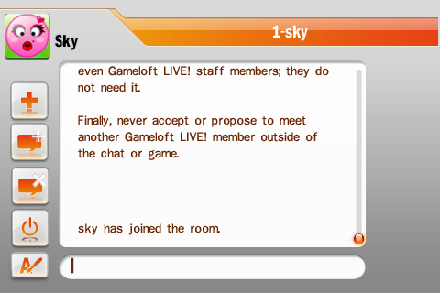
- each user can max creates 8 chatrooms
Room list
Touch to
switch
Touch to invite
friend
Touch leave
current chatroom
Touch leave
all chatrooms
Change the color
of font
Create new
chatroom
- each chatroom can max accommodate 20 users.

Send message: In fact, this screen is same as the send message screen in mail box, BUT the addressee is fill the name of the friends automatically
The max length of message= 256 characters

Compare games:
List all the user played games and his friend's. And each game's:
            - score
            - trophy
Delete friend(the red cross button): To delete the friend, if user touch the icon, there will be a warning”Are you sure to delete this friend?”. If you deleted one of you friend, notice that you also will be removed in his/her friend list.
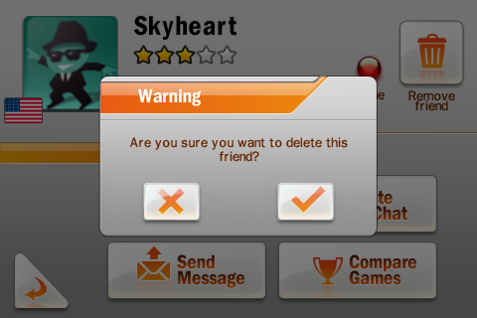

Evaluate friend:

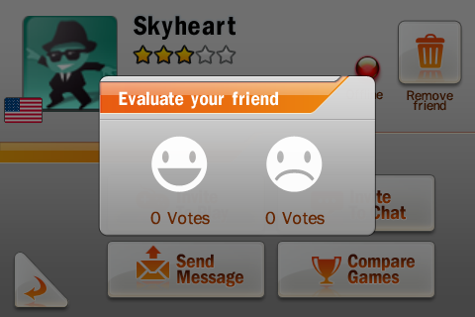
After playing the game with friend, the star of reputation will flash, user touch the star can go to the evaluate friend screen.
Every user has 2500 scores after registering.
The value of score is -1000 to 5000
The relation of star of reputation and score is:
score is -1000 to -1 user will have 0 star
score is 0 to 999 user will have 1 star
score is 1000 to 1999 user will have 2 star
score is 2000 to 2999 user will have 3 star
score is 3000 to 3999 user will have 4 star
score is 4000 to 5000 user will have 5 star

Message

Message box

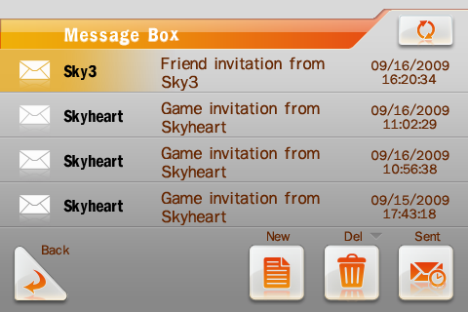
Write
message
Delete
message
double touch
to read
message
refresh
Touch to
view the sent
messages

All the messages store here, User can do those actions--- New, Delete, View sent messages, refresh
New: go to the write message screen
Delete message: Same as view, user need select a message before he delete, BUT after user touch the delete button, there will be a warning message. “Are you sure to delete the message?”
Read message: User need double touch the message to open it.
Sent: To enter a page, that listed all sent messages.

Read message
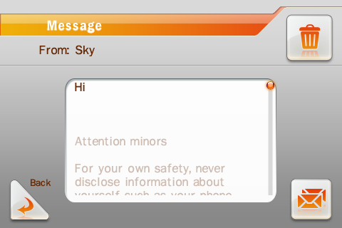
Reply
Add to friend list
Only appear when he
is not your friend

There are 3 buttons here, Reply, delete message, add to friend list.
Reply: Same function with Message box. BUT the addressee will fill the name who send to you automatically.
Delete message: Same as it in message box.
Add to friend list: This icon only appears when the addresser isn't your friend!

Write message

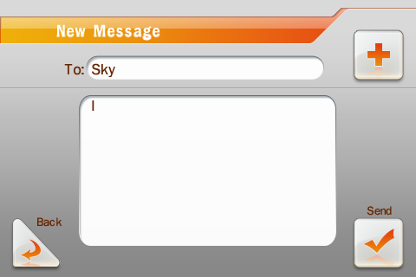
Add addressee
in friends list

We can send the message to others with input his user name, if we send message to friend, we also can touch the + button to select the one.
Max length of message= 180 characters

System message
System message contains notice and request, both of them can not be reply. notice is the system message to tell user some informations like the avatar evaluate successfully or not. If your friend invite you play game or someone wants to become your friend, system will send a request to you, you can accept or decline it.

User message
Users can communicate by send messages, max length= 180 characters.

Trophy

Trophy
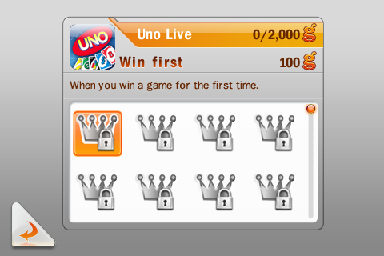
Once user played a gameloft game, The system will record the g poitn and accomplishment for the game. These data both viewable for user and his friend.
Every gameloft game should be record:
What's should we provide to server team for trophy:

- Game icon: 57*57 pixels with png format
- Trophy icon: 48*48 pixels with png format
- g point: defined the g points value of each trophy
- Each game should has total 2000 g ponit
- Trophy name: text description max length= 18
- Trophy description: text description max length=90

Of cause you can define trophies as many as you want, but let's keep the g ponit is total 2000.

Here is the ref of UNO:

Trophy account association
The game trophy achievement is associated with a Gameloft Live! account, so you must associate an account with a game. The association will be required when you enter trophy section, if
- You enter trophy section first time, that means no Gameoft Live! Account has been associated with current game in current device before.
- You logined with the account, which is not the current association account with the current game in current device, and enter trophy section then.

A confirmation dialog will be shown in the cases above. The current account will be associated with current game if you accept, of cause the old account associated will be replaced if exist. After that and before next association, all the trophy achievement in game will unlock the corresponding trophy of the account, and then upload to server when you login Gameloft Live! with this account.

There is a particular case. When you install a game, then start to play before login Gameloft Live!, and you achieves some trophies. In this case, The trophies will be award the first associated account and upload to server immediately after your first association.

Trophy account is independent of devices and games, and you can change it. But there is only one account associated with one game in one device at one time.

Compare games
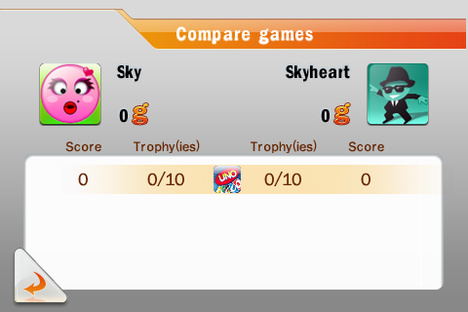
If user touch the compare games button on friend xxx screen, it will list the all games that user A played and user B play, user also can touch the game icon to detail compare screen.

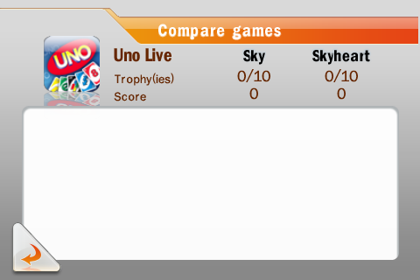

Push notification

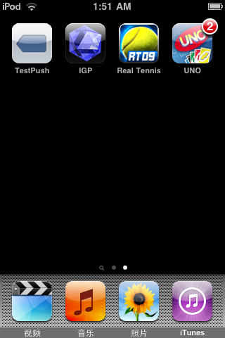
Push notification is a new feature on iphone SDK 3.0
- push notification: it's an alert message to display to the user, if you are offline and your friend invite you play game. There will be an alert message prompt out like this:
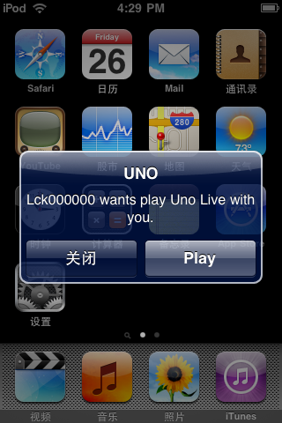
if you touch play, it will launch UNO automatically and go to the game room that hosted by your friend who invited you.

For invite play, those situation will be send by push notification:
    - when you invite a offline friend
    - when you invite a friend who is playing game(or running other apps) by not in GL live.
    - when you invite a friend in GL live, but you are not same game

But if you invite a friend to play and you are playing same game, it will send a system message to him/her with GL live message system, and if you accept, it will jump to the online multi play without restart the app.

Address list of GL live team

If you have any further questions please do not hesitate to ask.

Q&A

- Q:Will the trophy available which I unlocked in other gameloft game before?
A: Depends on whether you upload it to you GL account, if you unlocked the trophy, it will be upload to server when you across GL live. (But for the first time, you need enter the trophy page to associate the GL account with the game).

- Q:If player login GL live with UNO, player B login GL live with let's golf(B only has let's golf), then A invite B play UNO, what will happen?
A: Player B will receive a push notification with the url of UNO in app store, but it's not implemented yet.

- Q:How to enter GL live?
A: There's 2 way's:

1. GL live has an entrance in main menu of game, if you log in with the remember me ticked, next time you will log in without input username and password.

2. Same things for online multiplayer
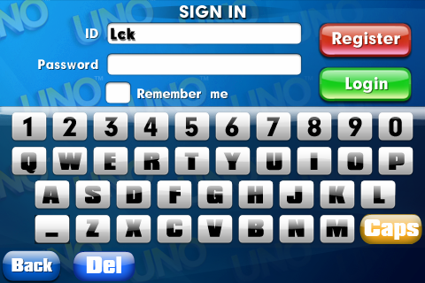

- Q: Do we need supply the gfx res of the style of our game?
A: No, GL live is a standard module like IGP, you only need supply a entrance in main menu.

